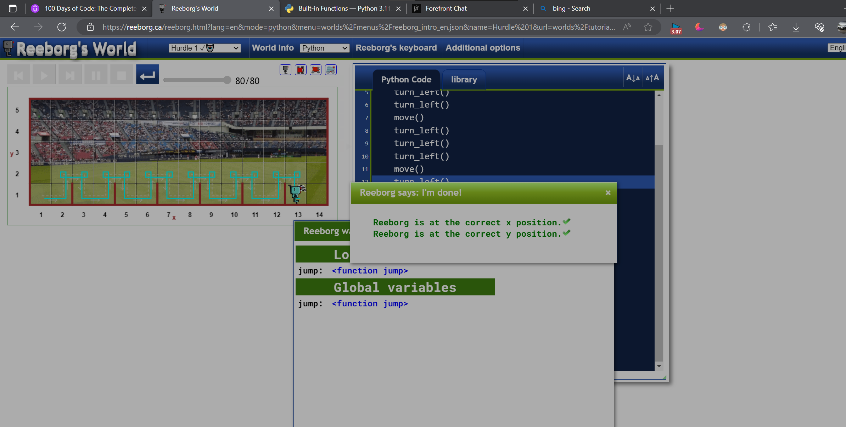

Lectures 60 th

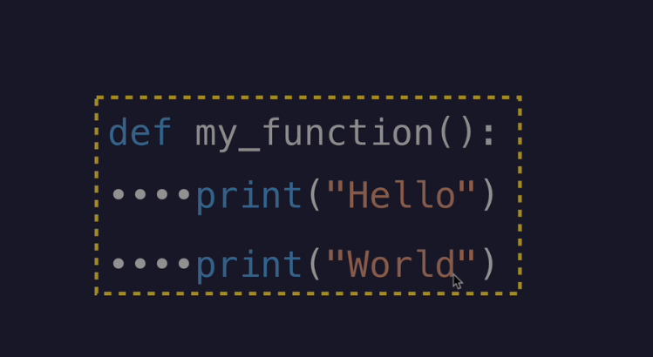

THIS IS THE IDENTATION

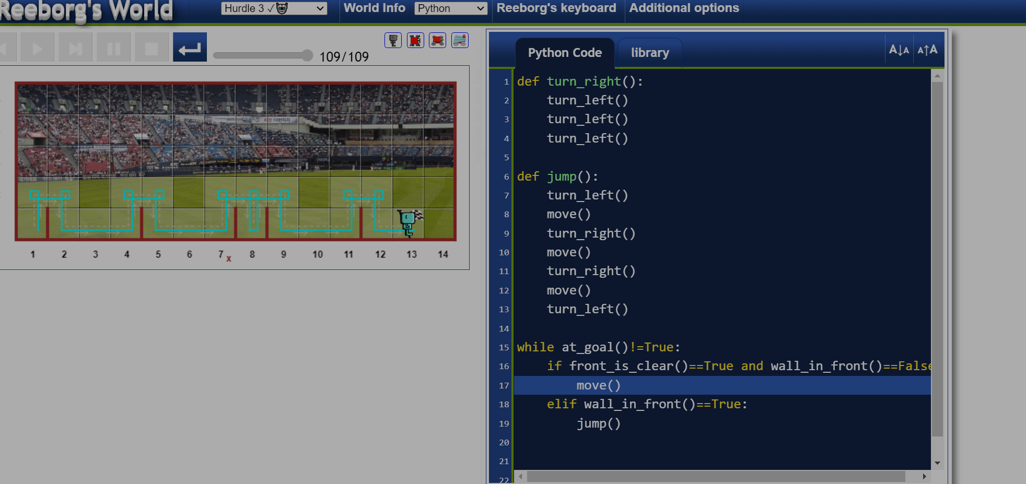

This is the code when every time some new hurdles are made out

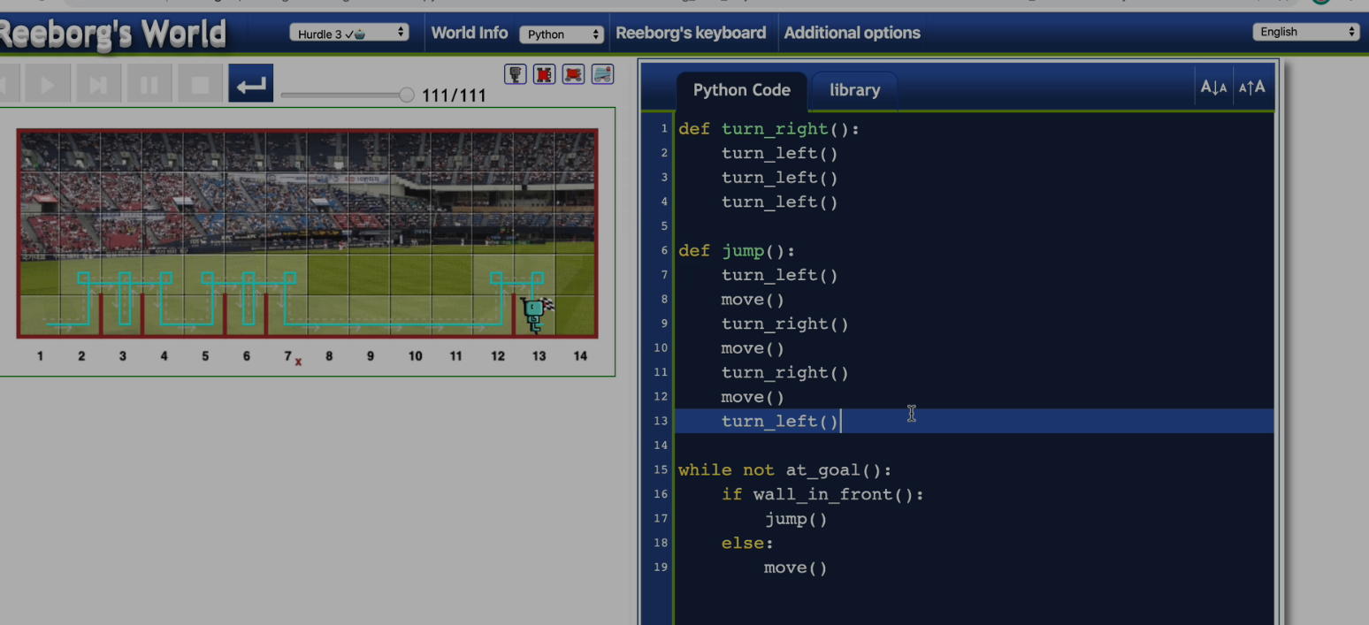

The solution given by the teacher is as above

Code of jump with variable heights

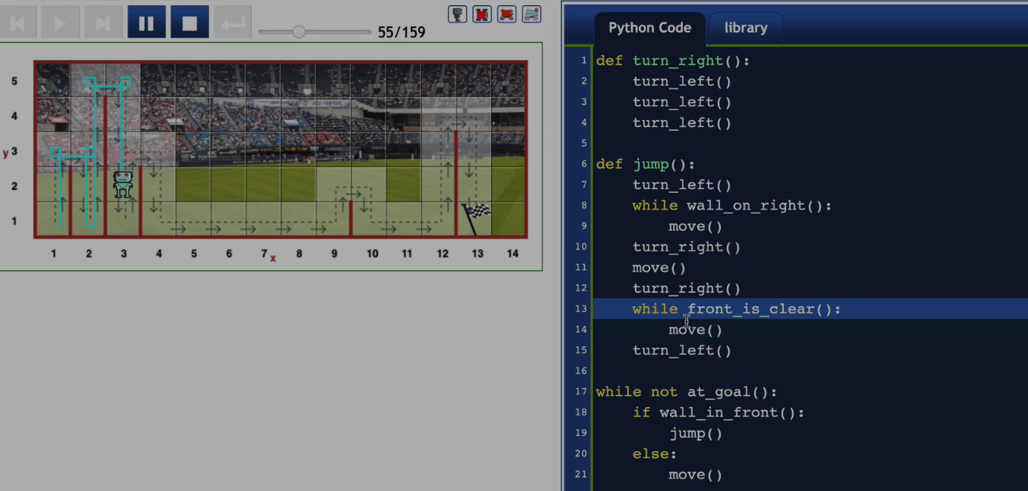

This is the code provided by the teacher

The hangman problem   
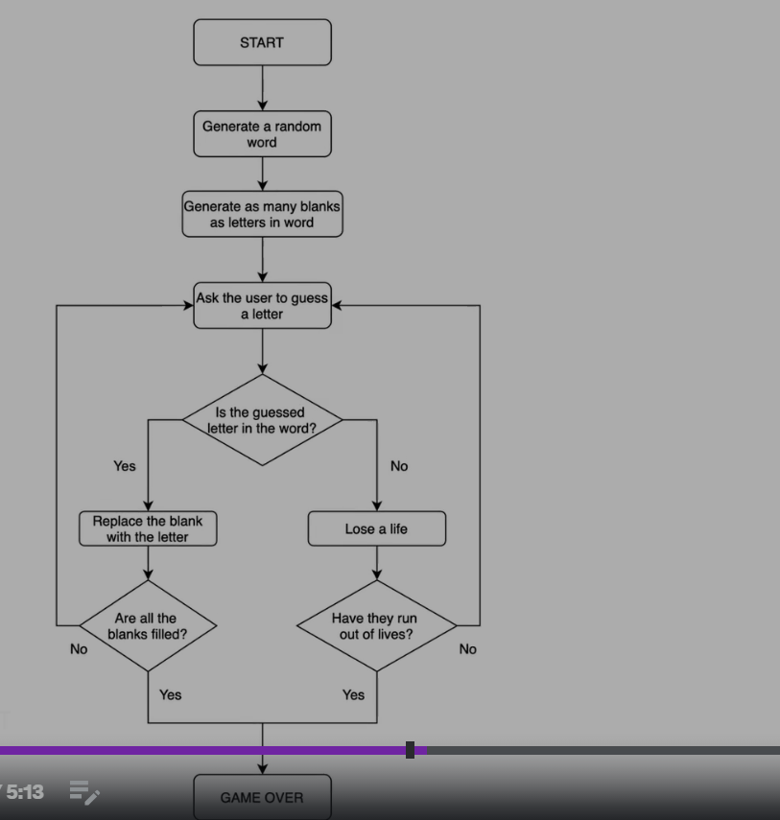  
this is the problem flow chart

Two ways to get the index no of the given sequence   
1.   
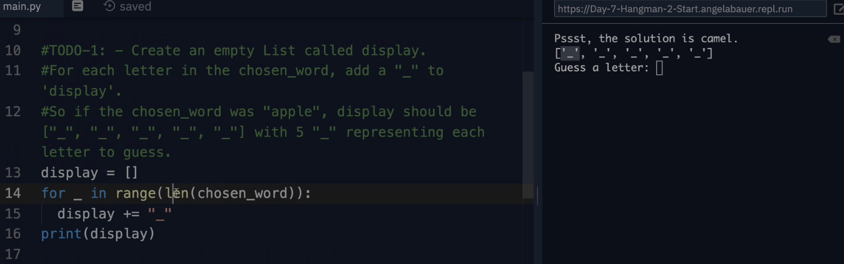using the len() function

2.   
using the find() function   
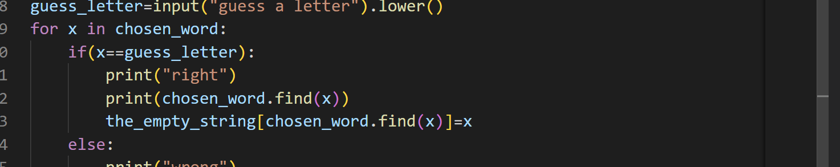

The find() function is the one

***The enumerate function***

The enumerate() function in Python is a built-in function that allows you to iterate over an iterable object while keeping track of the index and the corresponding element. It returns an enumerate object, which contains pairs of index and element values.

The syntax for the enumerate() function is as follows:

python

Copy

*enumerate*(iterable, start=0)

The iterable parameter represents the object you want to iterate over, such as a list, tuple, or string. The start parameter is optional and specifies the starting index value. By default, it starts from 0.

Here's an example of how to use the enumerate() function:

python

Copy

fruits = ['apple', 'banana', 'orange']

*for* index, fruit *in* *enumerate*(fruits):

*print*(index, fruit)

Output:

Copy

0 apple

1 banana

2 orange

In this example, the enumerate() function is used to iterate over the fruits list. The index variable represents the index of each element, and the fruit variable represents the corresponding element value.

You can also specify a different starting index by passing it as the second argument to the enumerate() function. For example:

python

Copy

fruits = ['apple', 'banana', 'orange']

*for* index, fruit *in* *enumerate*(fruits, start=1):

*print*(index, fruit)

Output:

Copy

1 apple

2 banana

3 orange

In this case, the enumeration starts from 1 instead of the default 0.

The enumerate() function is useful when you need to iterate over an iterable object and also keep track of the index. It eliminates the need to manually manage the index variable in a loop, making your code more concise and readable.

While two files being in the same folder   
then importing of the variables and the initials within the files is possible

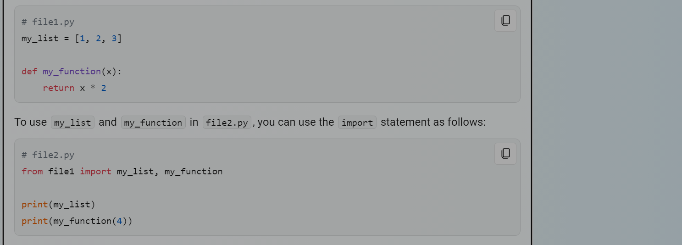

this is the way of importing elements from one list to another list.

***We can also import the object in the module using the following***

Import <python_file_name>  
<The_python_file_name.object>

IN ORDER to clear the screen after every iteration   
we use the replit module   
and the clear screen function

***Ctrl + L is the shortcut key to clear the screen***

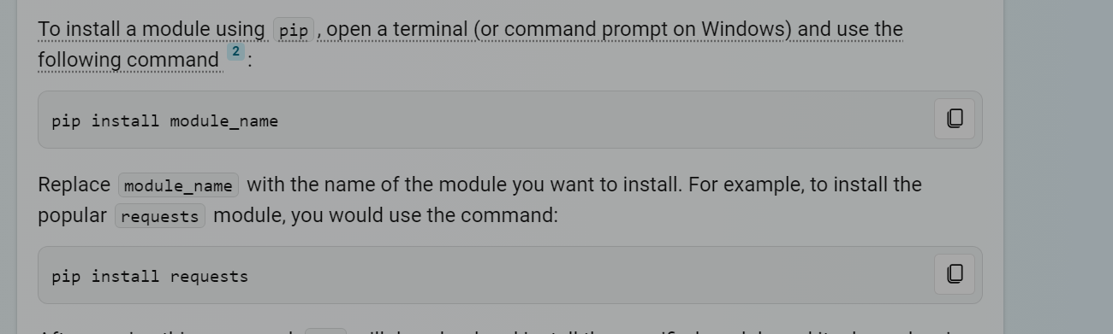

Above is the way to install a module using the terminal

***What does the actually the pip command means in the above command?***

pip stands for “Pip Installs Packages” or “Pip Installs Python”. [It is a package manager for Python that allows you to install and manage additional packages (i.e., modules) that are not part of the Python standard library 1](https://www.w3schools.com/python/python_pip.asp).

pip works by downloading and installing packages from the Python Package Index (PyPI), which is a repository of Python packages maintained by the Python community. Using pip, you can easily install, upgrade, and remove packages, as well as manage package dependencies.